Supporting Information Appendix:

Evaluating drivers of spatiotemporal individual condition of a bottom-associated marine fish

Max Lindmarka,1, Sean C. Andersonb,c, Mayya Gogina d, Michele Casinia,e

a Swedish University of Agricultural Sciences, Department of Aquatic Resources, Institute of Marine Research, Turistgatan 5, 453 30 Lysekil, Sweden

b Pacific Biological Station, Fisheries and Oceans Canada, Nanaimo, BC, Canada

c Simon Fraser University, Department of Mathematics, Burnaby, BC, Canada

d Leibniz Institute for Baltic Sea Research, Seestraße 15, 18119 Rostock, Germany

e University of Bologna, Department of Biological, Geological and Environmental Sciences, Via Selmi 3, 40126 Bologna, Italy

1 Author to whom correspondence should be addressed. Current address:

Max Lindmark, Swedish University of Agricultural Sciences, Department of Aquatic Resources, Institute of Marine Research, Turistgatan 5, 453 30 Lysekil, Sweden, Tel.: +46(0)104784137, email: [max.lindmark@slu.se](mailto:max.lindmark@slu.se)

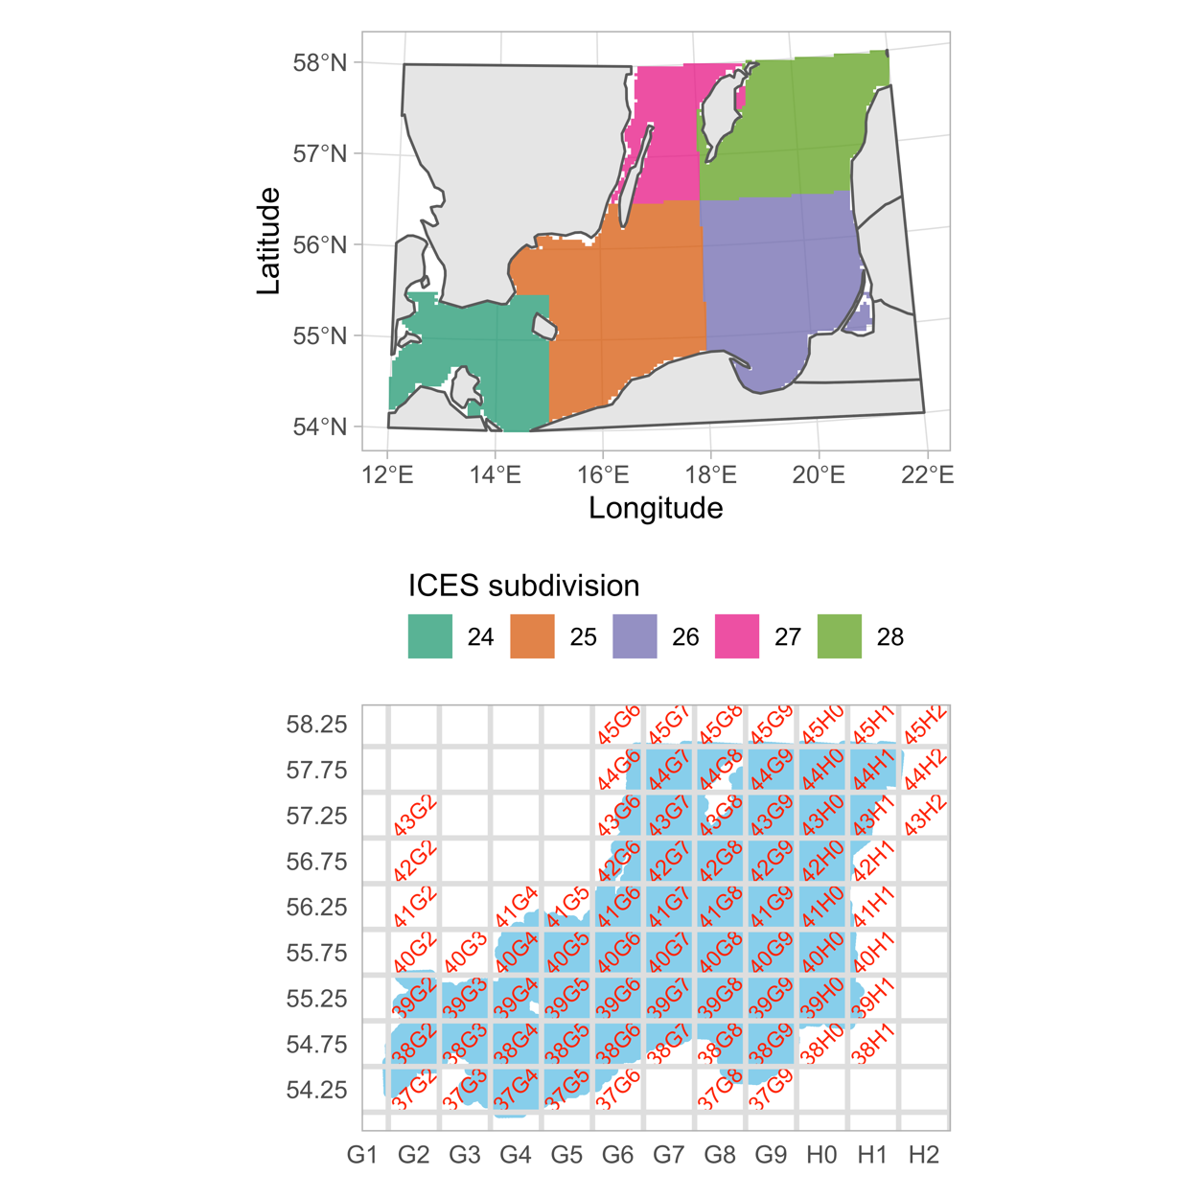

Fig. S1. Map of ICES subdivisions (top) and ICES rectangles (bottom).

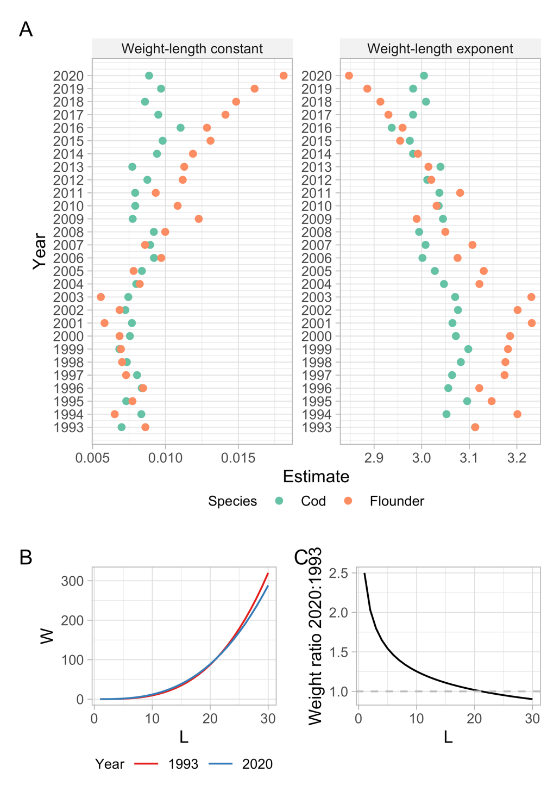

Fig. S2. A) Estimates of the constant ($a$) (left) and exponent ($b$) (right) of the weight-length relationship fitted for each year on log scale for cod and flounder, such that the intercept is the natural log of the constant and the slope is the exponent. B) Predicted weight for two representative parameter combinations ( $a=0.006$ and $b=3.2$ in 1993 (red), and $a=0.015$ and $b=2.9$ in 2020 (blue)). C) Ratio between predicted weight in 2020 to 1993, over length. Note though these estimates may not represent population-level estimates since the difference in the size-distribution has not been controlled for. Rather, the aim of these year-specific estimates was to convert catches in numbers to biomass for the density models.

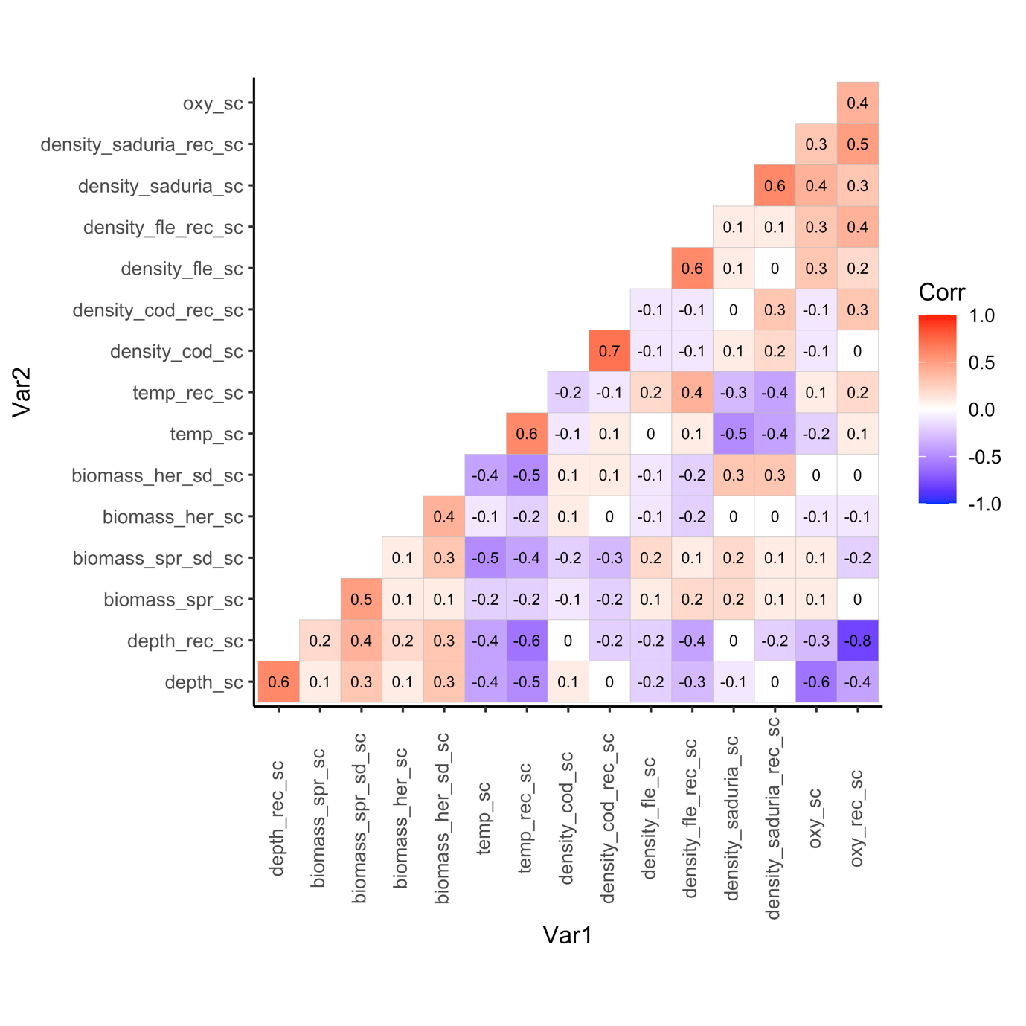

Fig. S3. Pearson correlations coefficients between all variables included in the condition model.

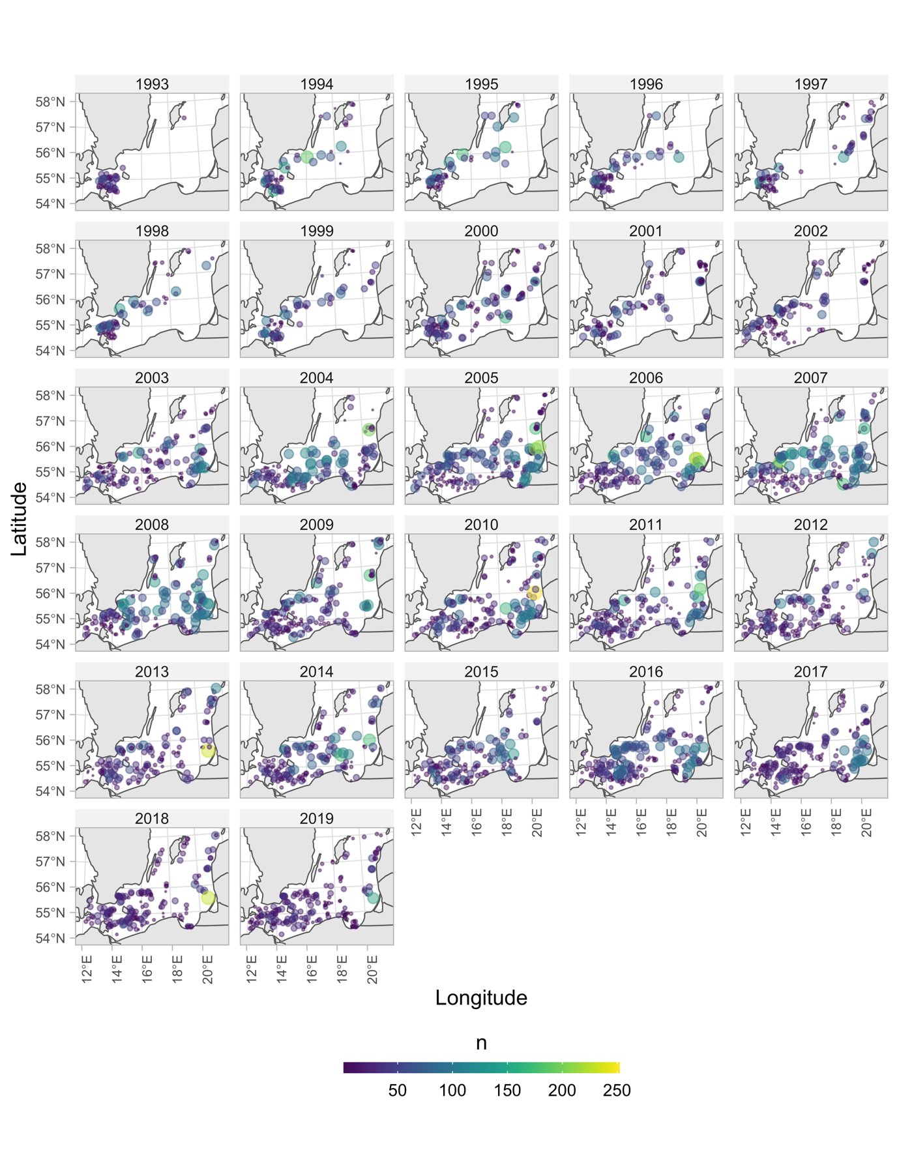

Fig. S4. Location and sample size (point size and color) per haul of condition data for all years included in the study.

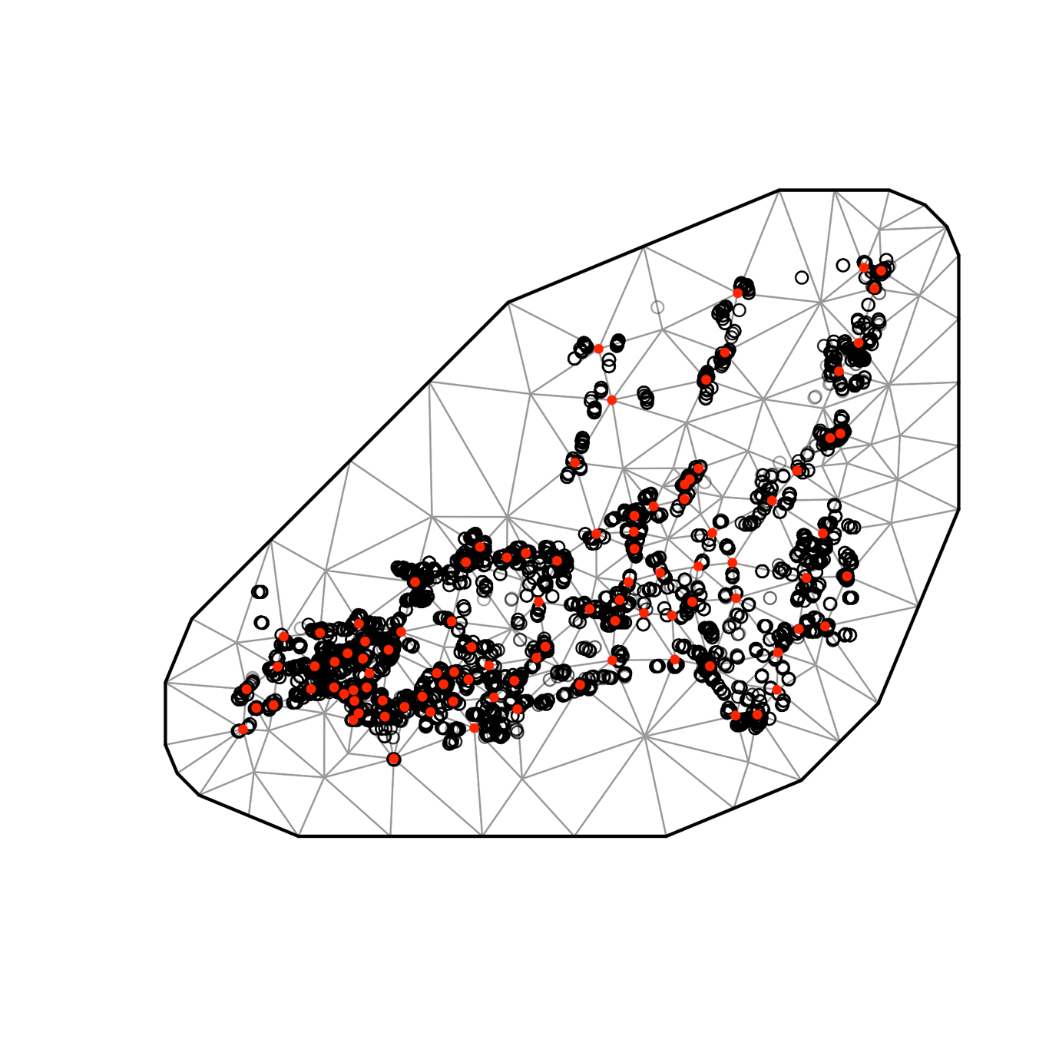

Fig. S5. SPDE mesh for condition model (100 knots).

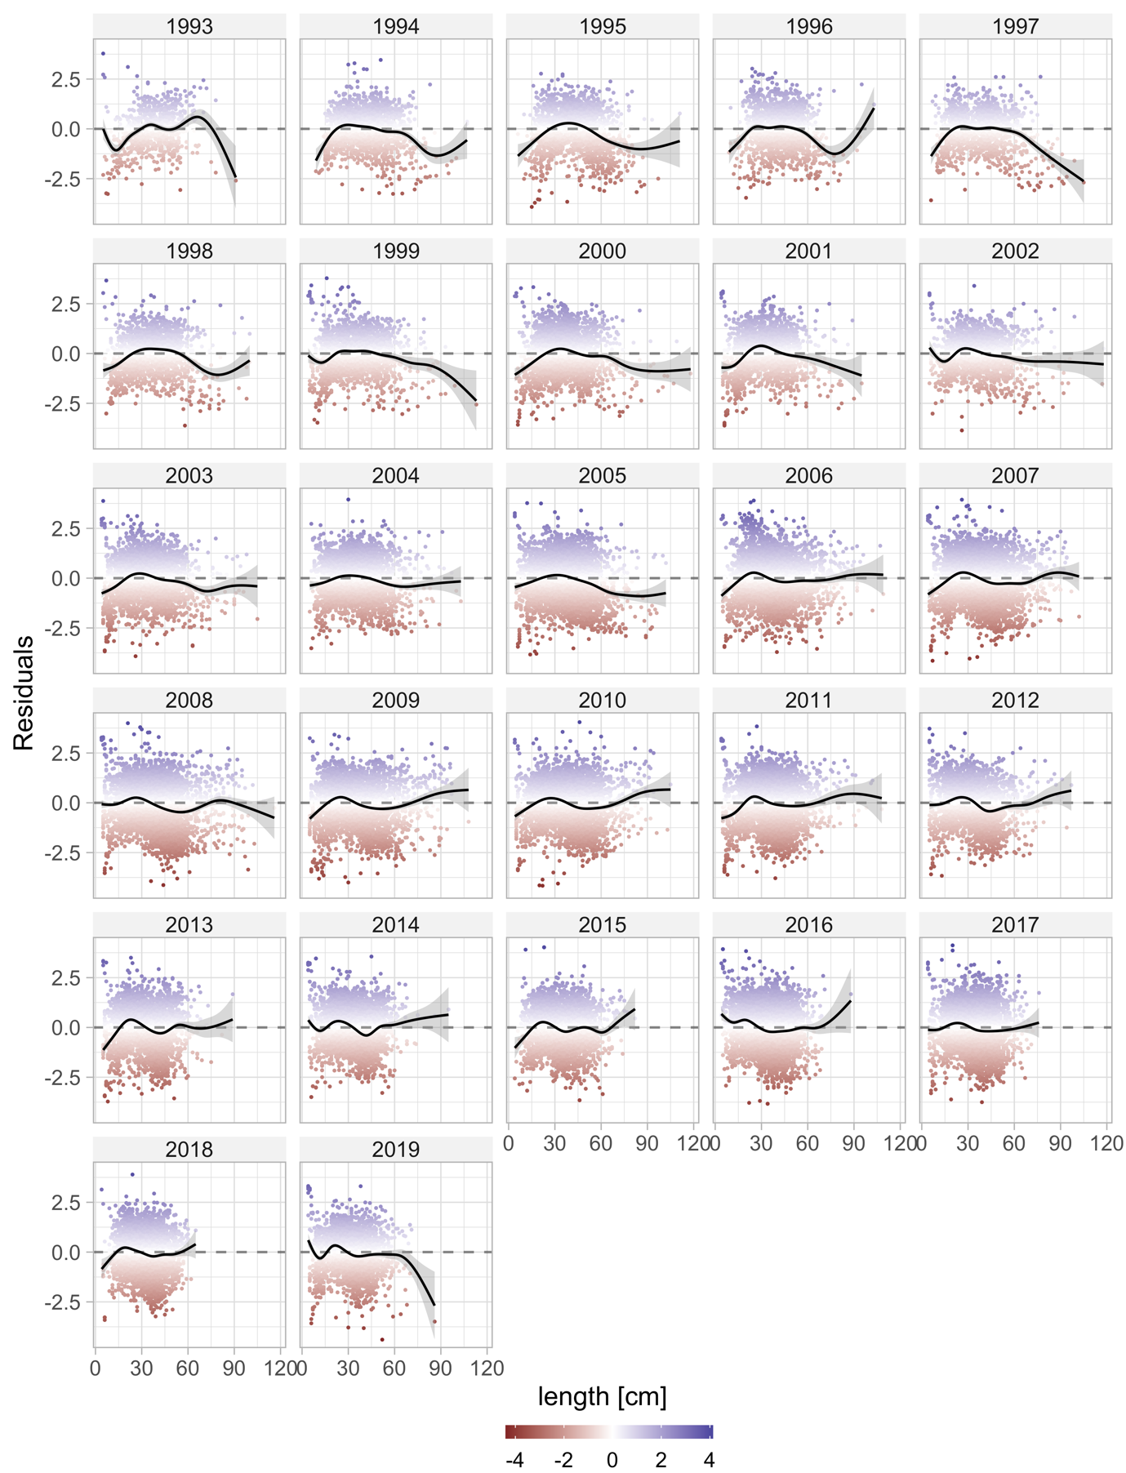

Fig. S6. Residuals from the condition model plotted against length for each year.

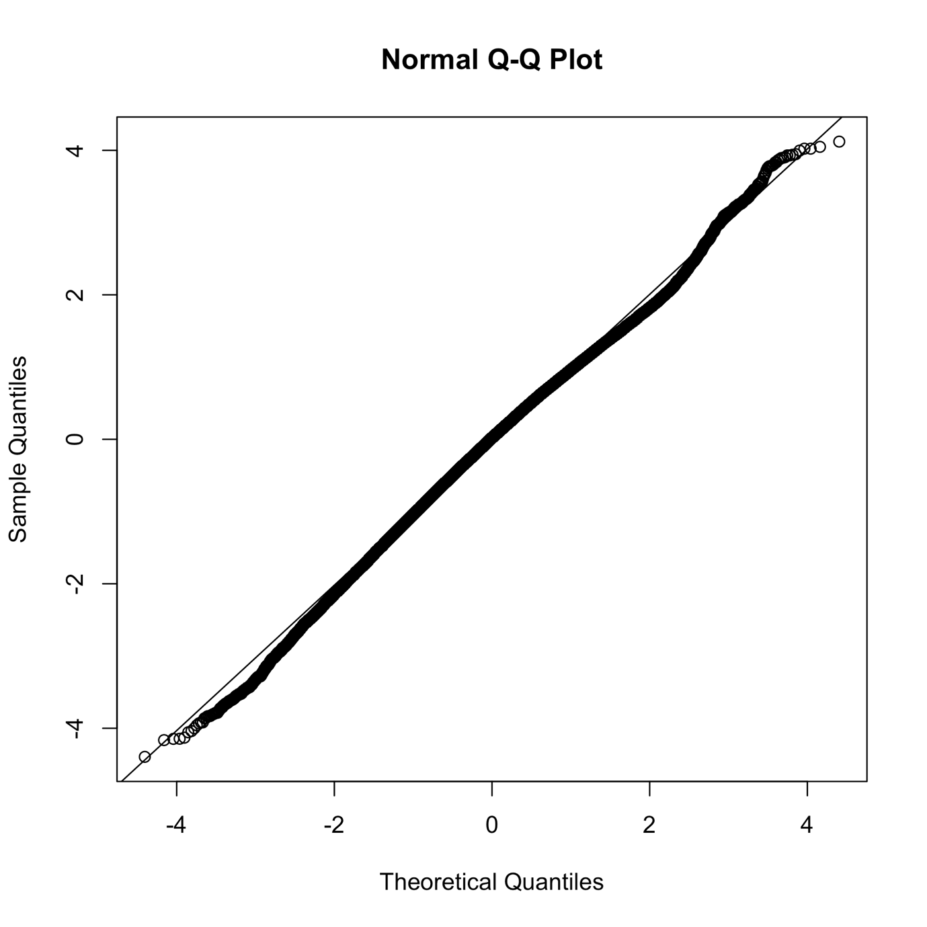

Fig. S7. QQ plot of condition model based on randomized quantile residuals (fixed effects held at their maximum likelihood estimate and the random effects are sampled with MCMC via `tmbstan` (Monnahan and Kristensen, 2018) and Stan (Stan Development Team, 2022), in line with (Thygesen *et al.*, 2017; Rufener *et al.*, 2021).

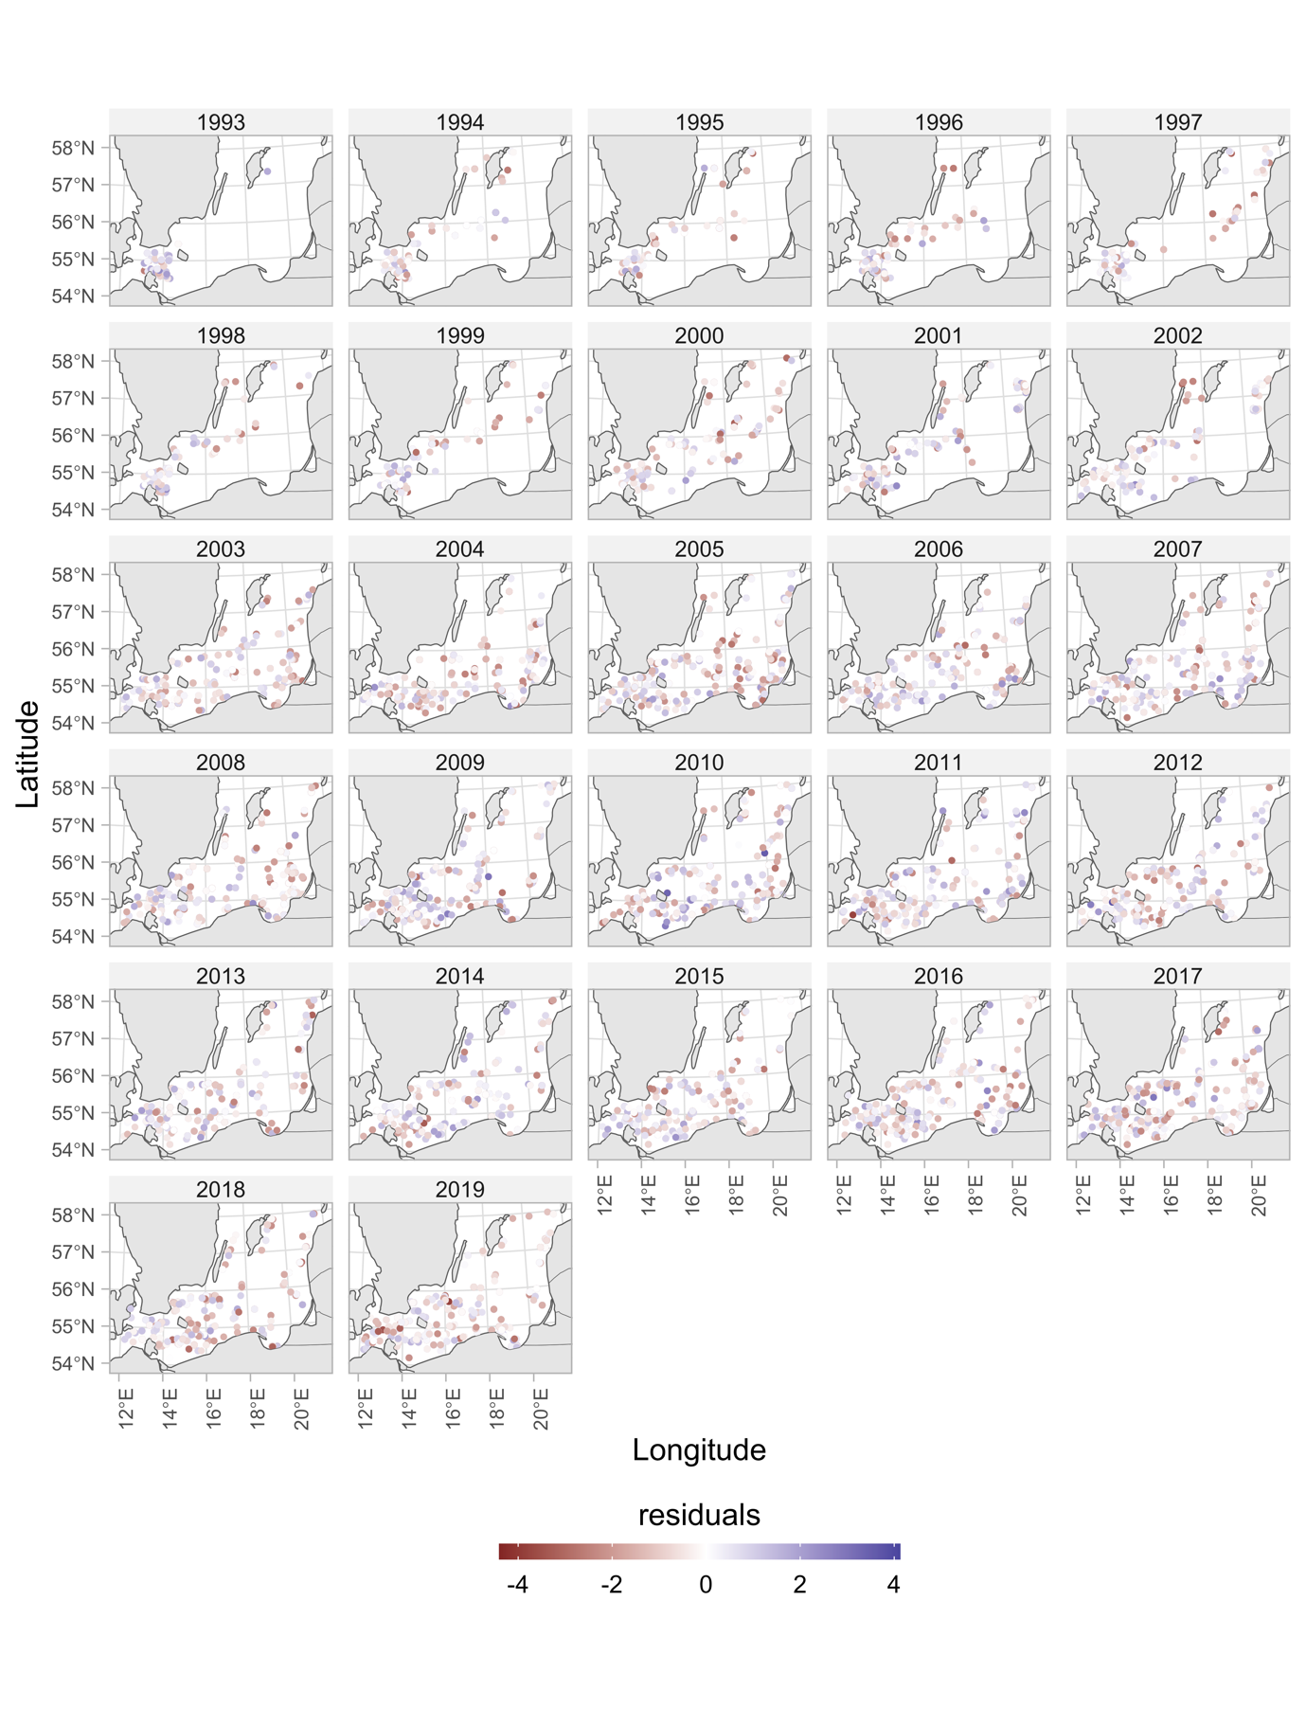

Fig. S8. Condition model residuals plotted in space.

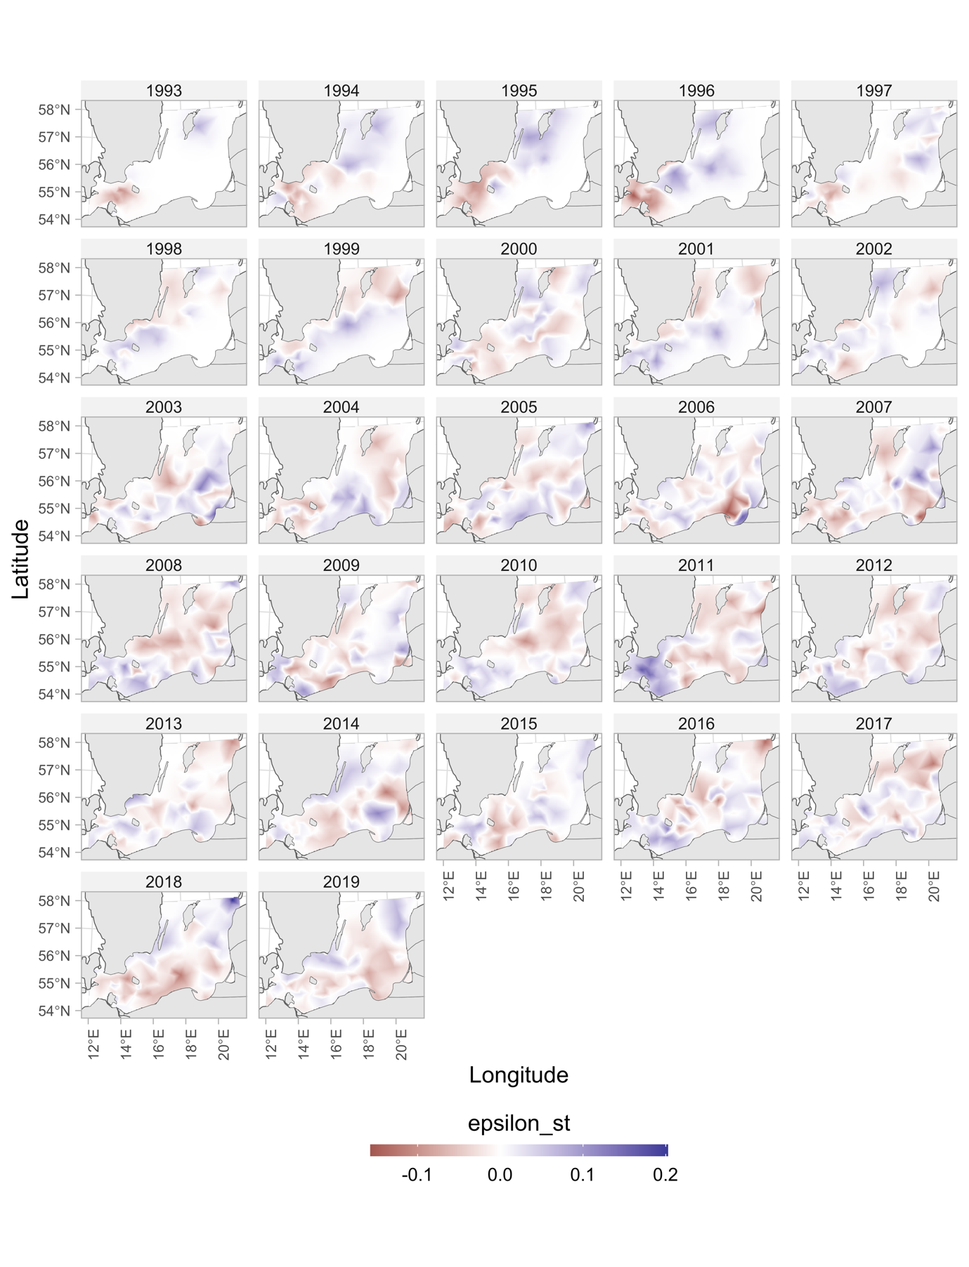

Fig. S9. Spatiotemporal random effects for the condition model.

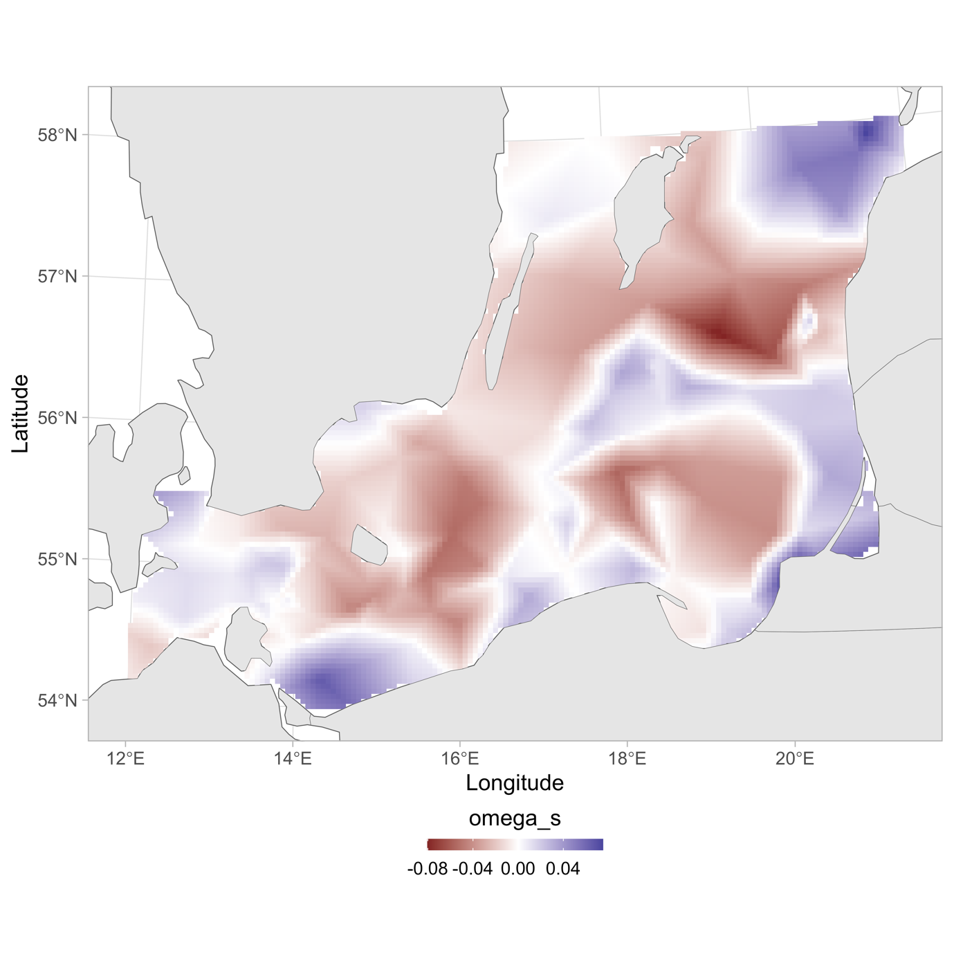

Fig. S10. Spatial random effects for the condition model.

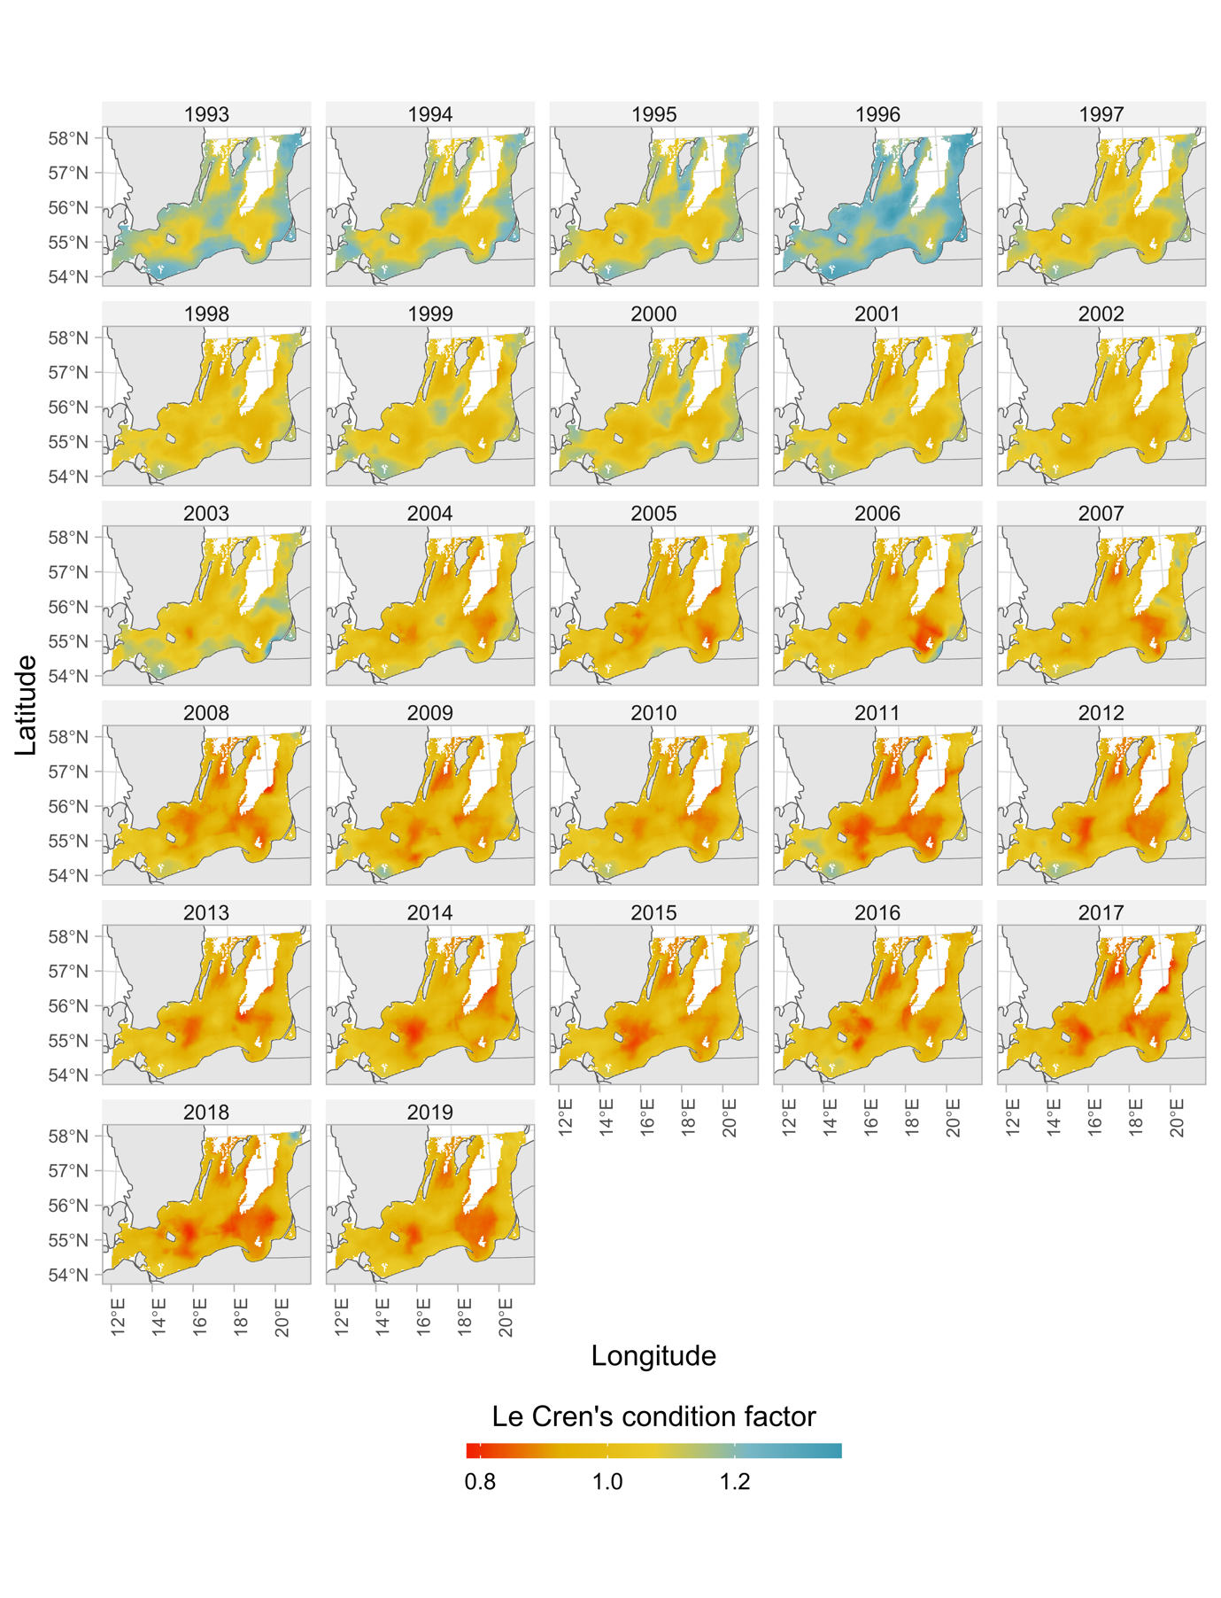

Fig. S11. Predicted condition factor with spatially varying covariates set to their true values (ICES rectangles with missing pelagic data were given the subdivision mean, see *SI Appendix*, Fig. S24). Only depths between 10 and 110 meters are included in the prediction grid.

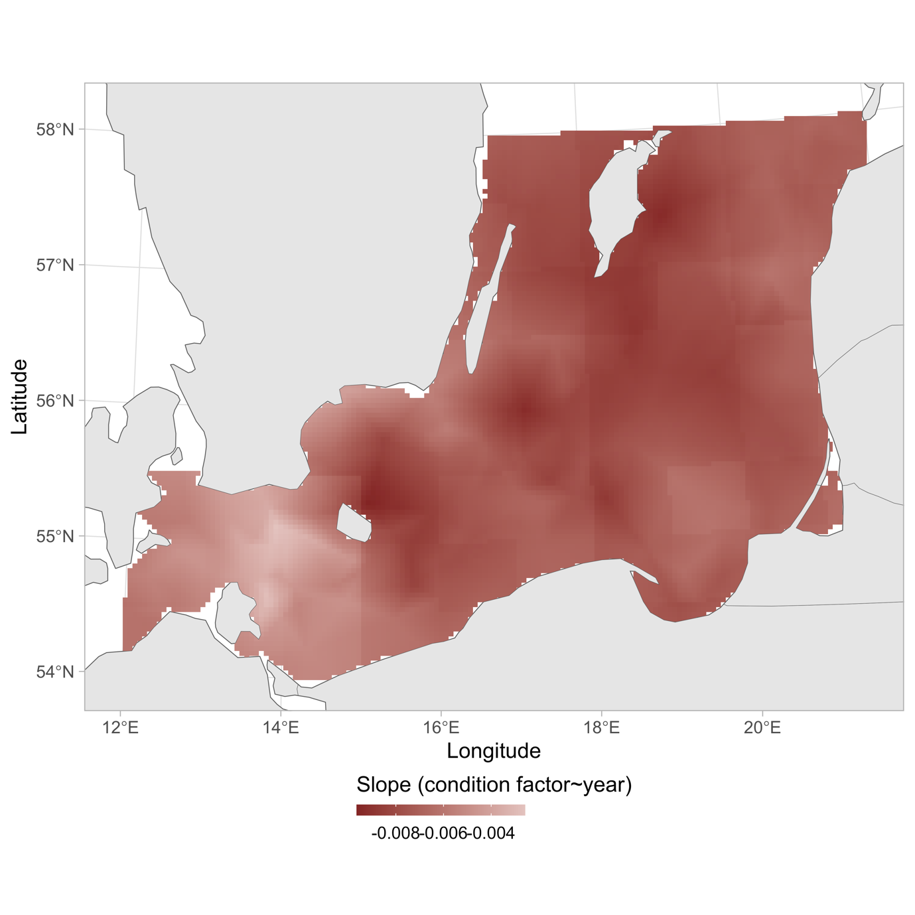

Fig. S12. Predicted condition factor with spatially varying covariates set to their true values (ICES rectangles with missing pelagic data were given the subdivision mean, see *SI Appendix*, Fig. S24). Only depths between 10 and 110 meters are included in the prediction grid.

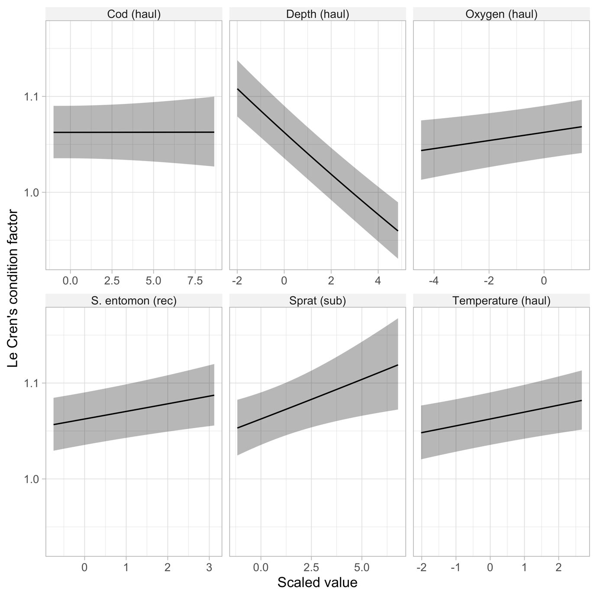

Fig. S13. Conditional effects from the condition model for selected covariates.

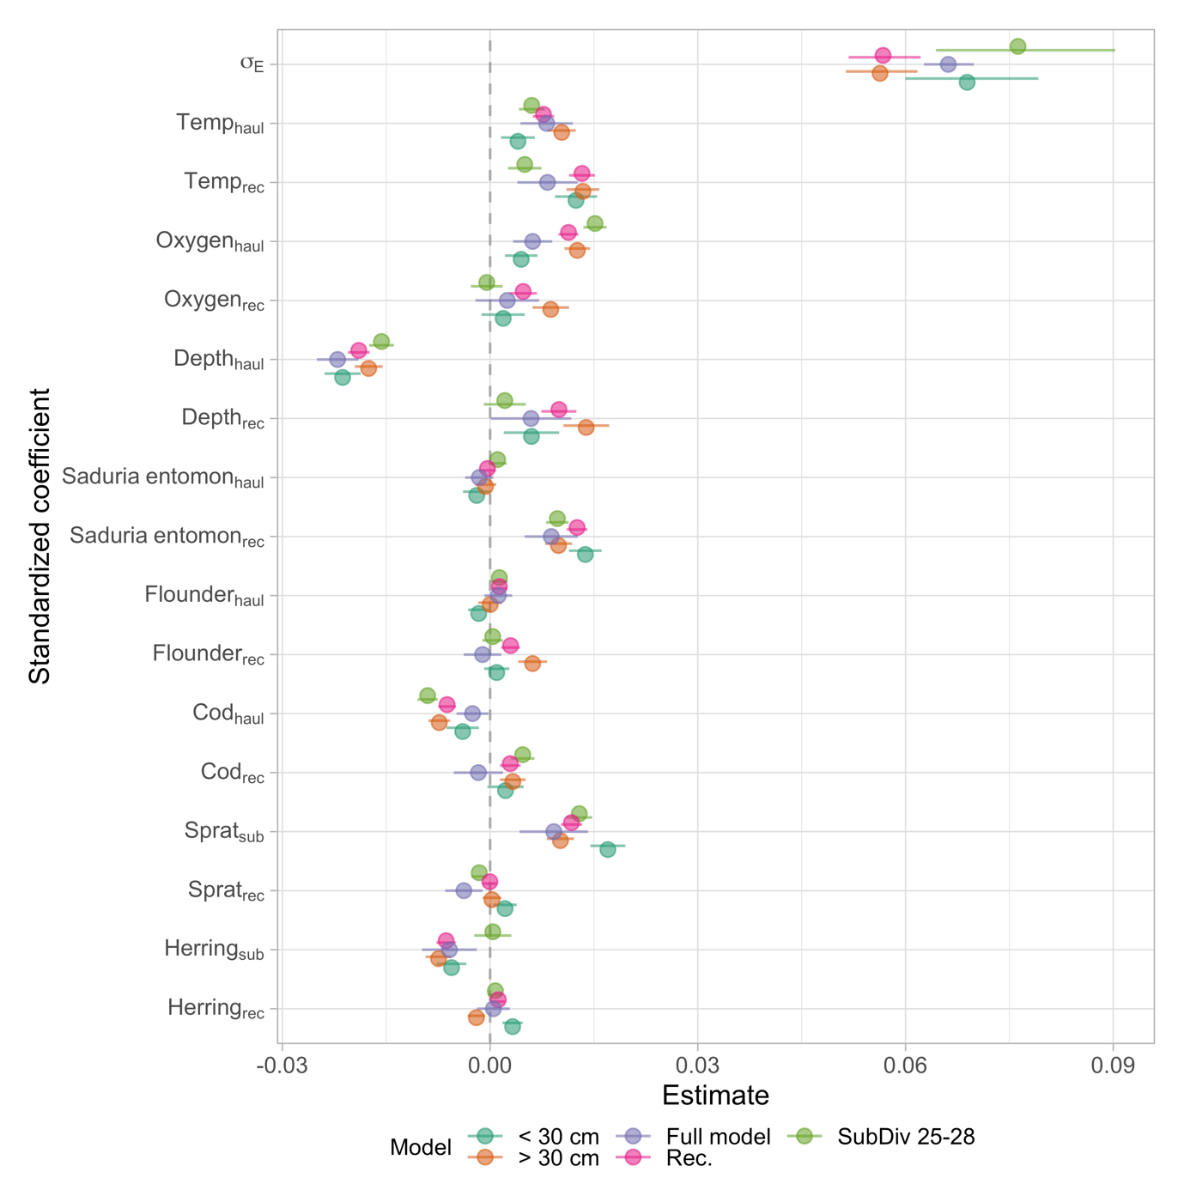

Fig. S14. Sensitivity analysis of the condition model. Colors indicate model; Purple is the main model, teal is a model fitted only to cod below 30 cm, orange only above 30 cm (these models test if the coefficients are sensitive to the gradual ontogenetic diet shift cod exhibit). The green points stem from a model fitted to only subdivision 25–28, which corresponds to the core area of the eastern Baltic cod (subdivision 24 is a mixing zone between the distinct eastern and western Baltic cod). The pink points stem from a model where the rectangle-level medians of the covariates were calculated only using points on the grid with cod densities larger than the 5th percentile. Horizontal lines correspond to the 95% confidence interval). The spatial random field was omitted from the model and only the spatiotemporal random field was included, as it led to better convergence across models.

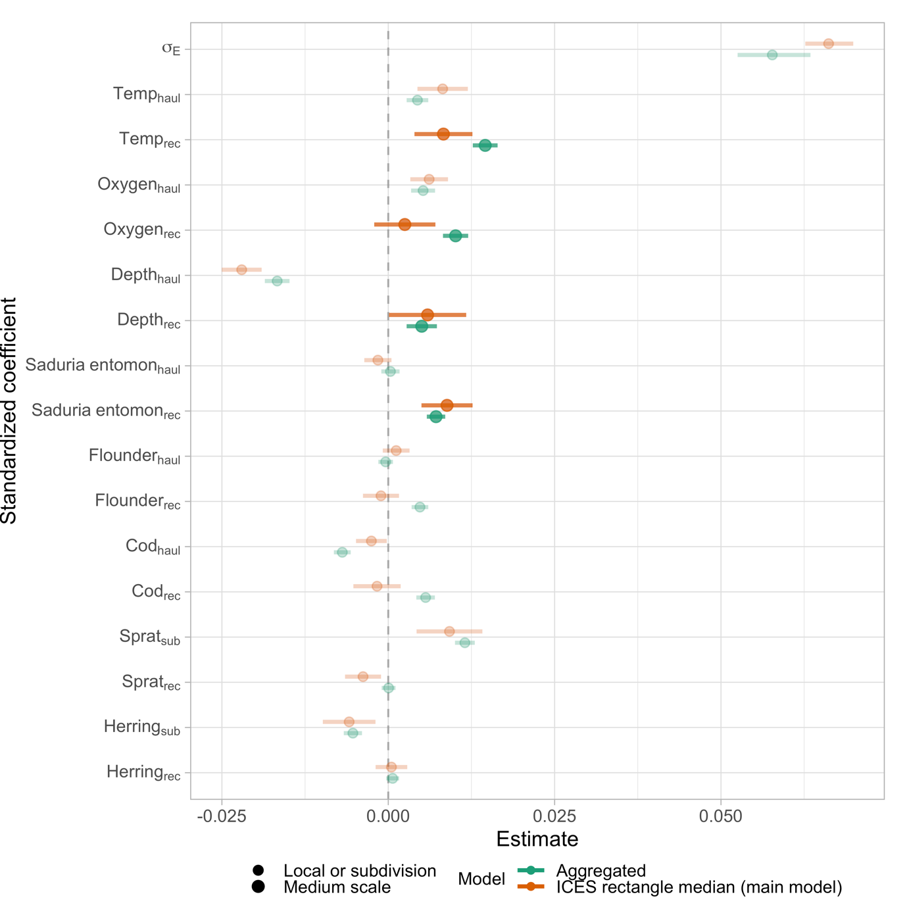

Fig. S15. Sensitivity analysis of the condition model. Colors indicate model; orange is the main model and green points and error bars correspond to a model where the ICES rectangle-level covariates were replaced by the average raster value within an area roughly corresponding to the area of an ICES rectangle, and then extracted pointwise using bilinear interpolation. Variables that remained the same between models are semi-transparent and smaller. The spatial random field was omitted from the model and only the spatiotemporal random field was included, as it led to better convergence across models.

Table S1. Comparison between models with oxygen as a linear effect (Eq. 6, main text) or as a linear breakpoint effect. The same model formulation was used as for the main model (Eqns. 1-4 in main text), but only covariates year (factor), oxygen (with or without threshold formula) and a linear effect for average oxygen in the ICES subdivision. The oxygen term is scaled (mean-centered and divided by the standard deviation). The (scaled) breakpoint estimate of 0.511 corresponds to an oxygen concentration of 6.52 in units ml/L.

|  |  |  |  |
| --- | --- | --- | --- |
| Model | Slope estimate  (Standard error) | Breakpoint estimate (Standard error) | AIC |
| Linear term | 0.0118 (0.00123) | NA | -145198 |
| Linear breakpoint term | 0.0092 (0.00164) | 0.511 (0.276) | -145234 |

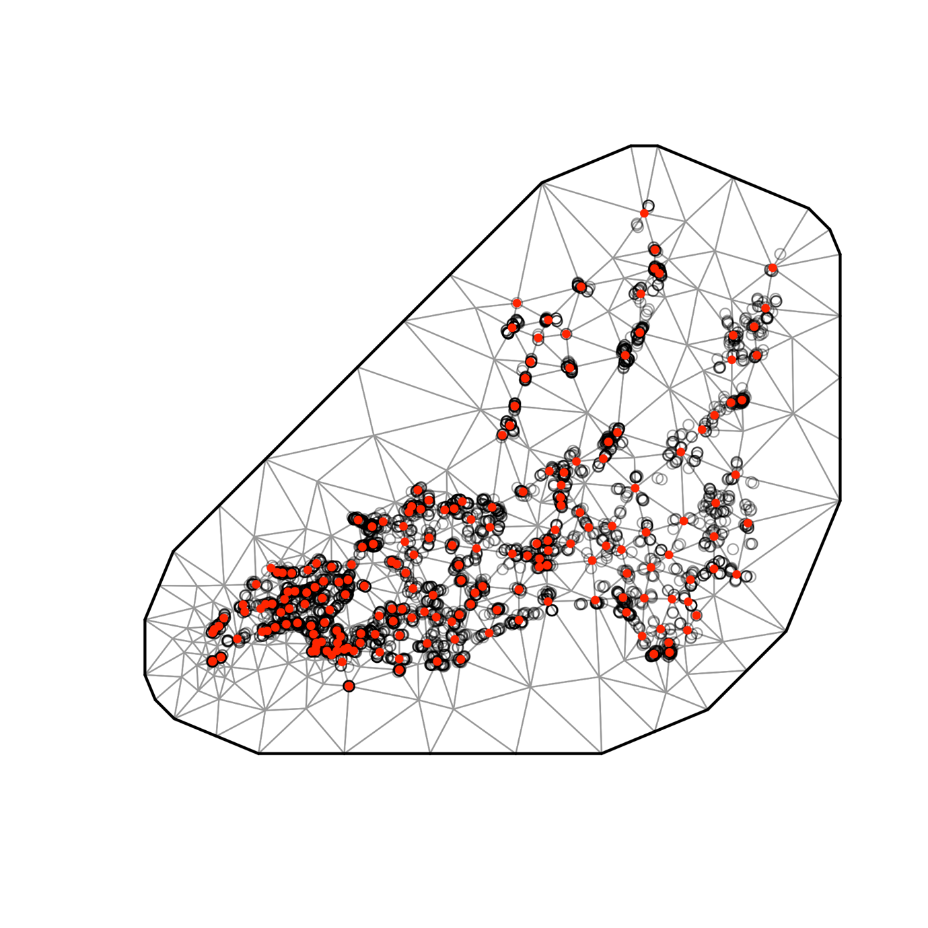

Fig. S16. SPDE mesh for the cod density model (200 knots).

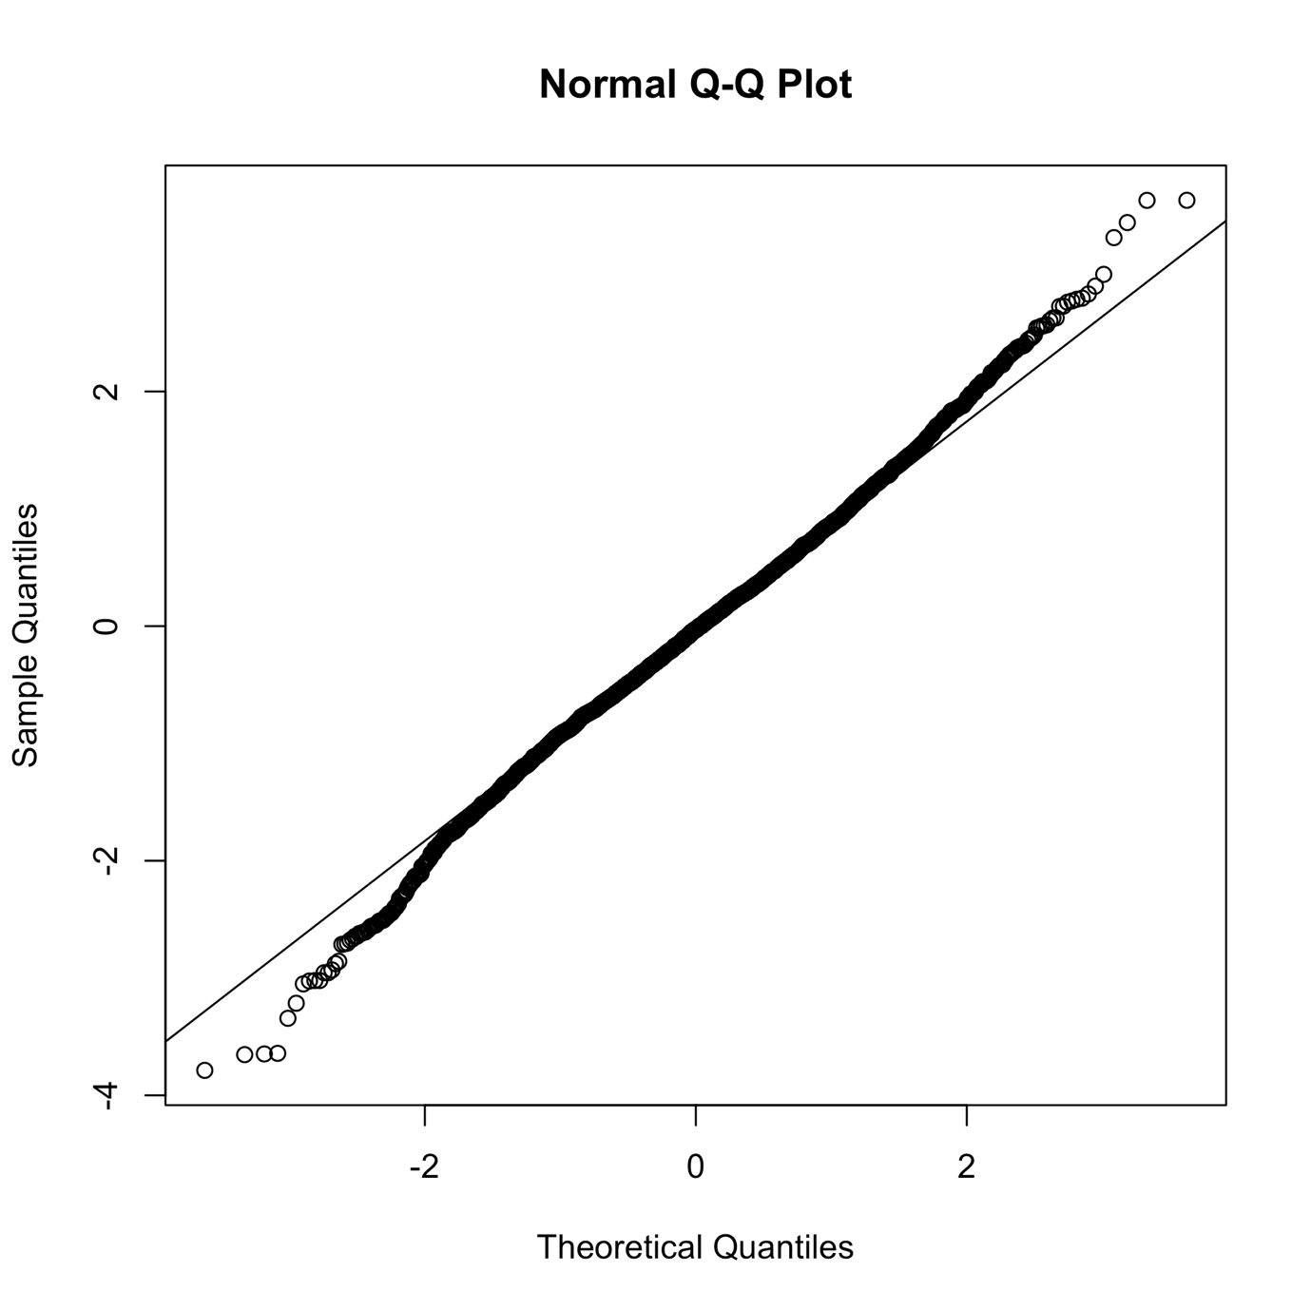

Fig. S17. QQ plot of cod density model based on randomized quantile residuals (fixed effects held at their maximum likelihood estimate and the random effects are sampled with MCMC via ‘tmbstan’ (Monnahan and Kristensen, 2018) and ‘Stan’ (Stan Development Team, 2022), in line with (Thygesen *et al.*, 2017; Rufener *et al.*, 2021).

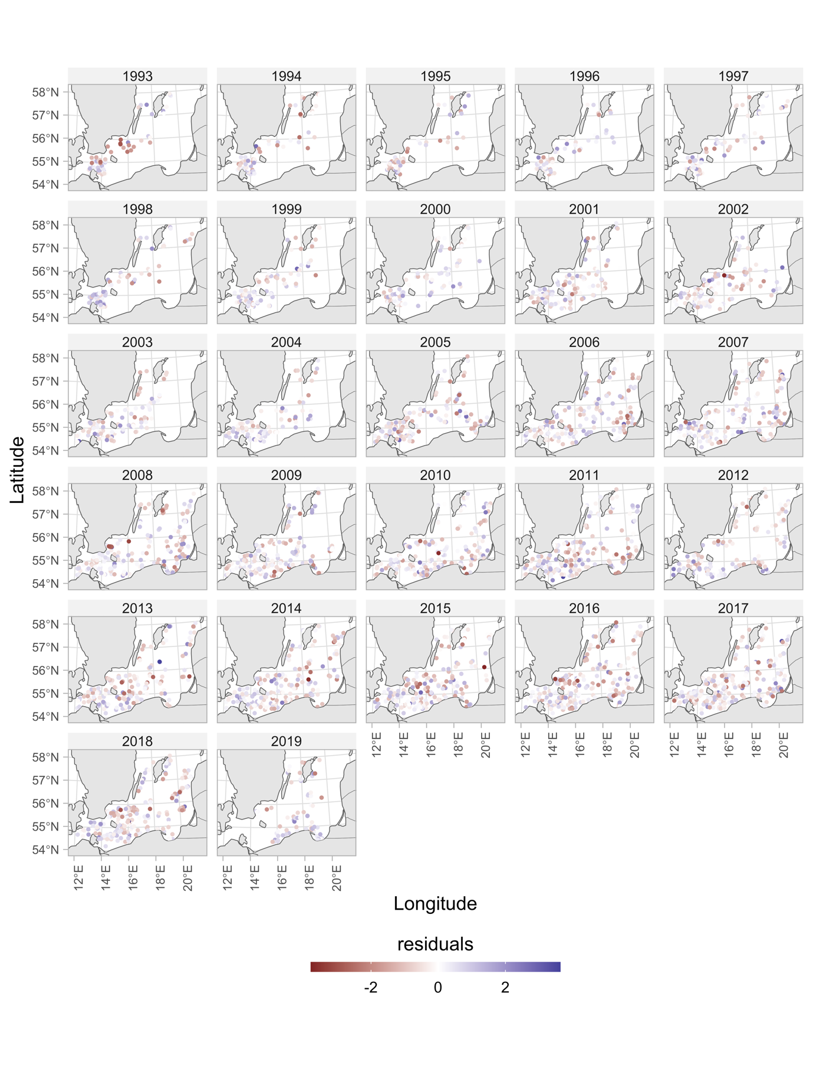

Fig. S18. Cod density model residuals plotted in space.

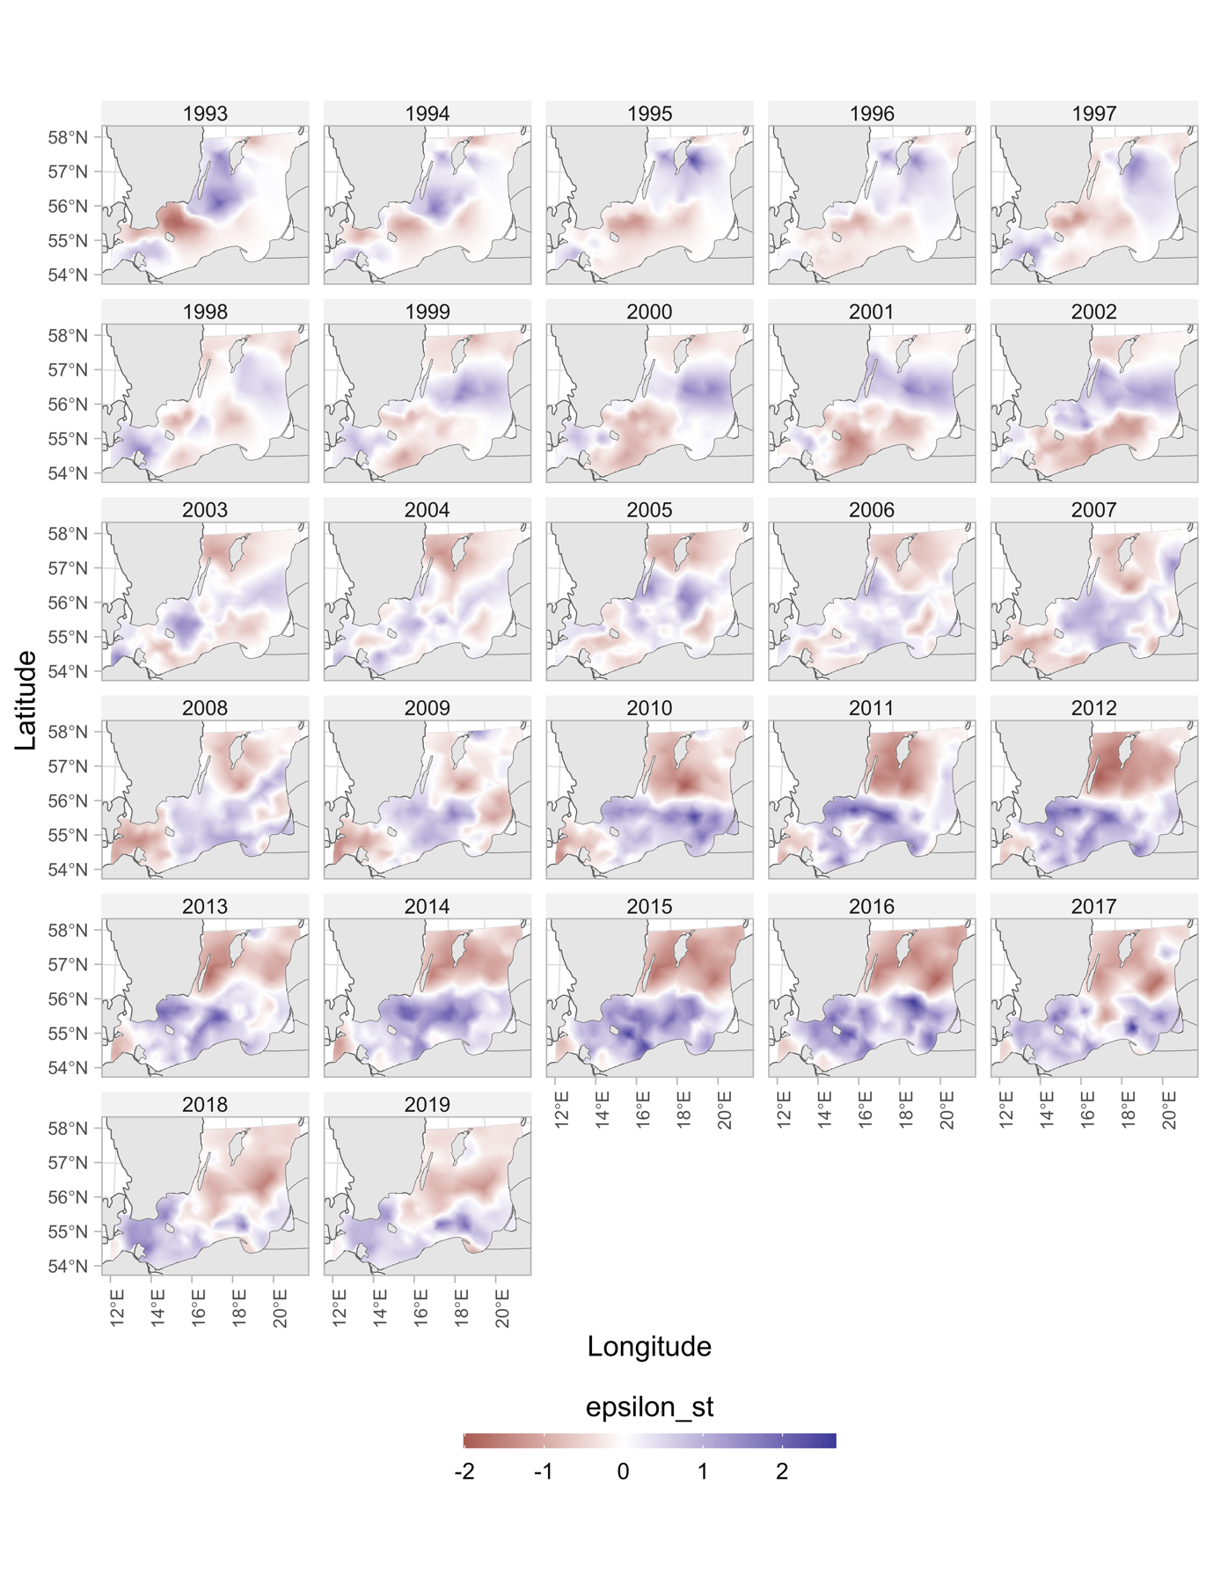

Fig. S19. Spatiotemporal random effects for the cod density model.

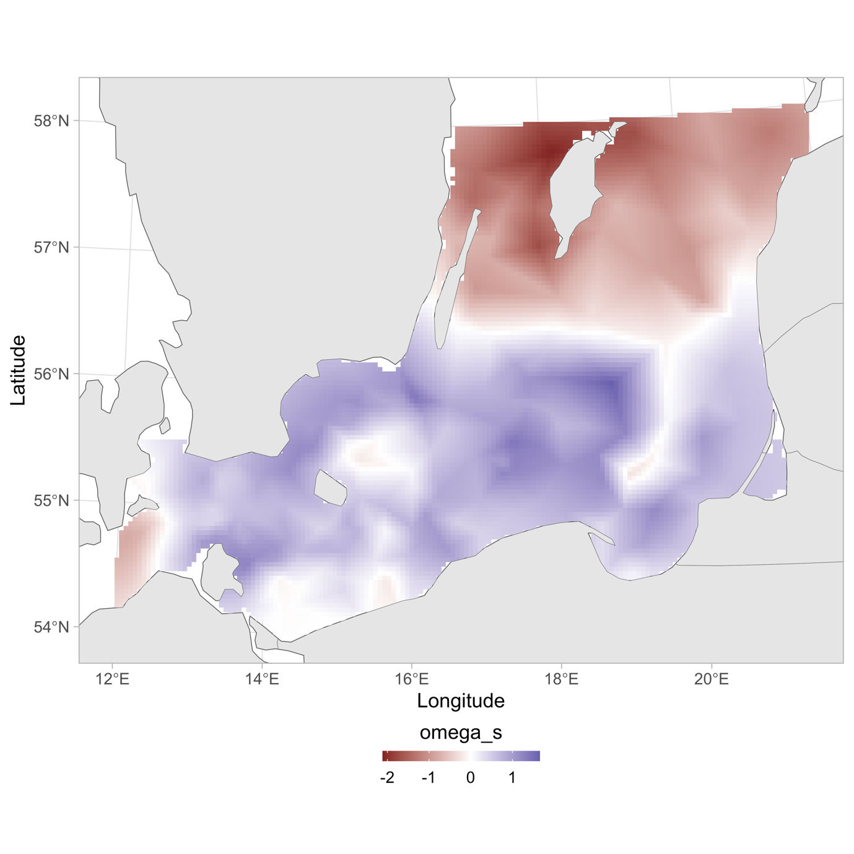

Fig. S20. Spatial random effects for the cod density model.

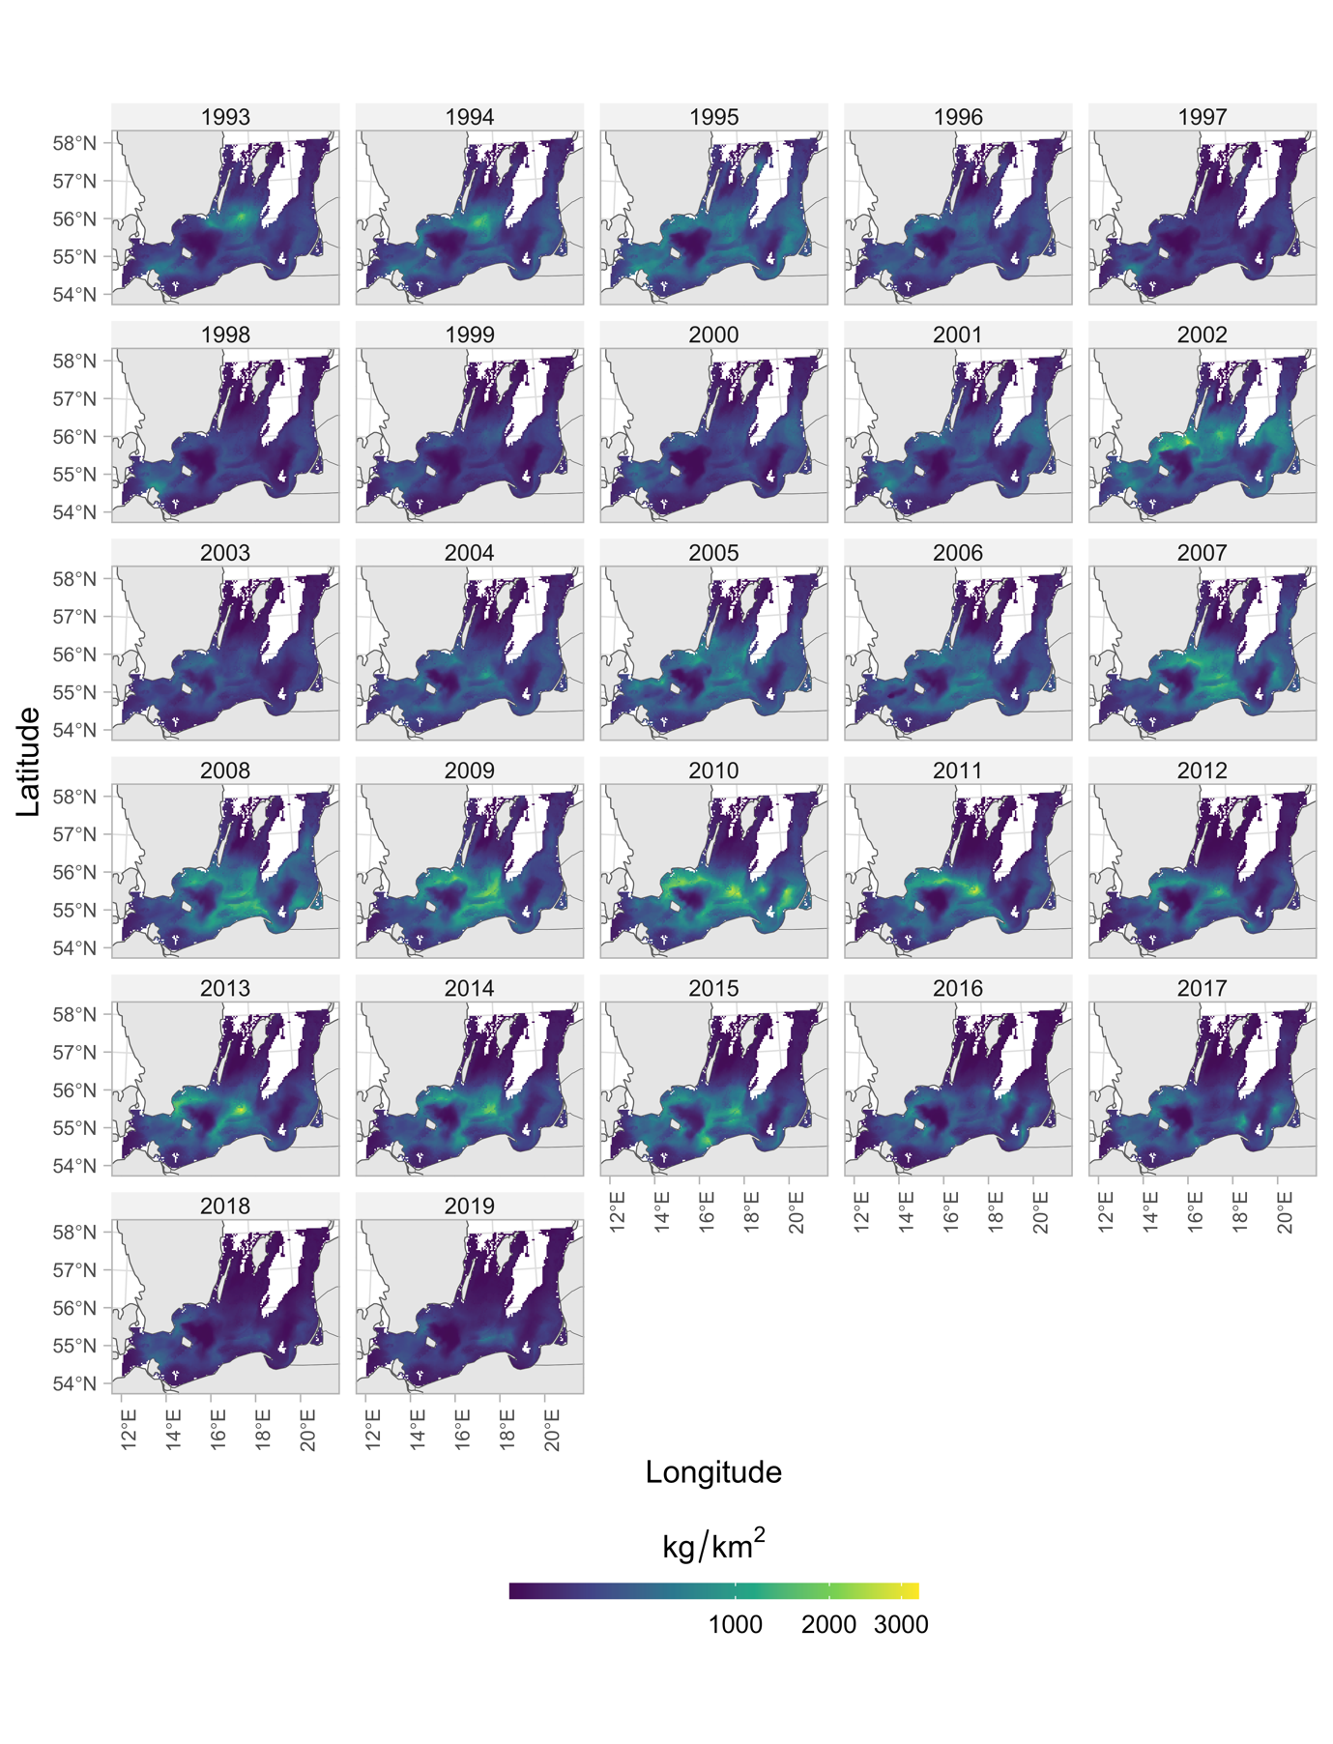

Fig. S21. Predicted cod density in space and time with covariates depth, oxygen, and temperature.

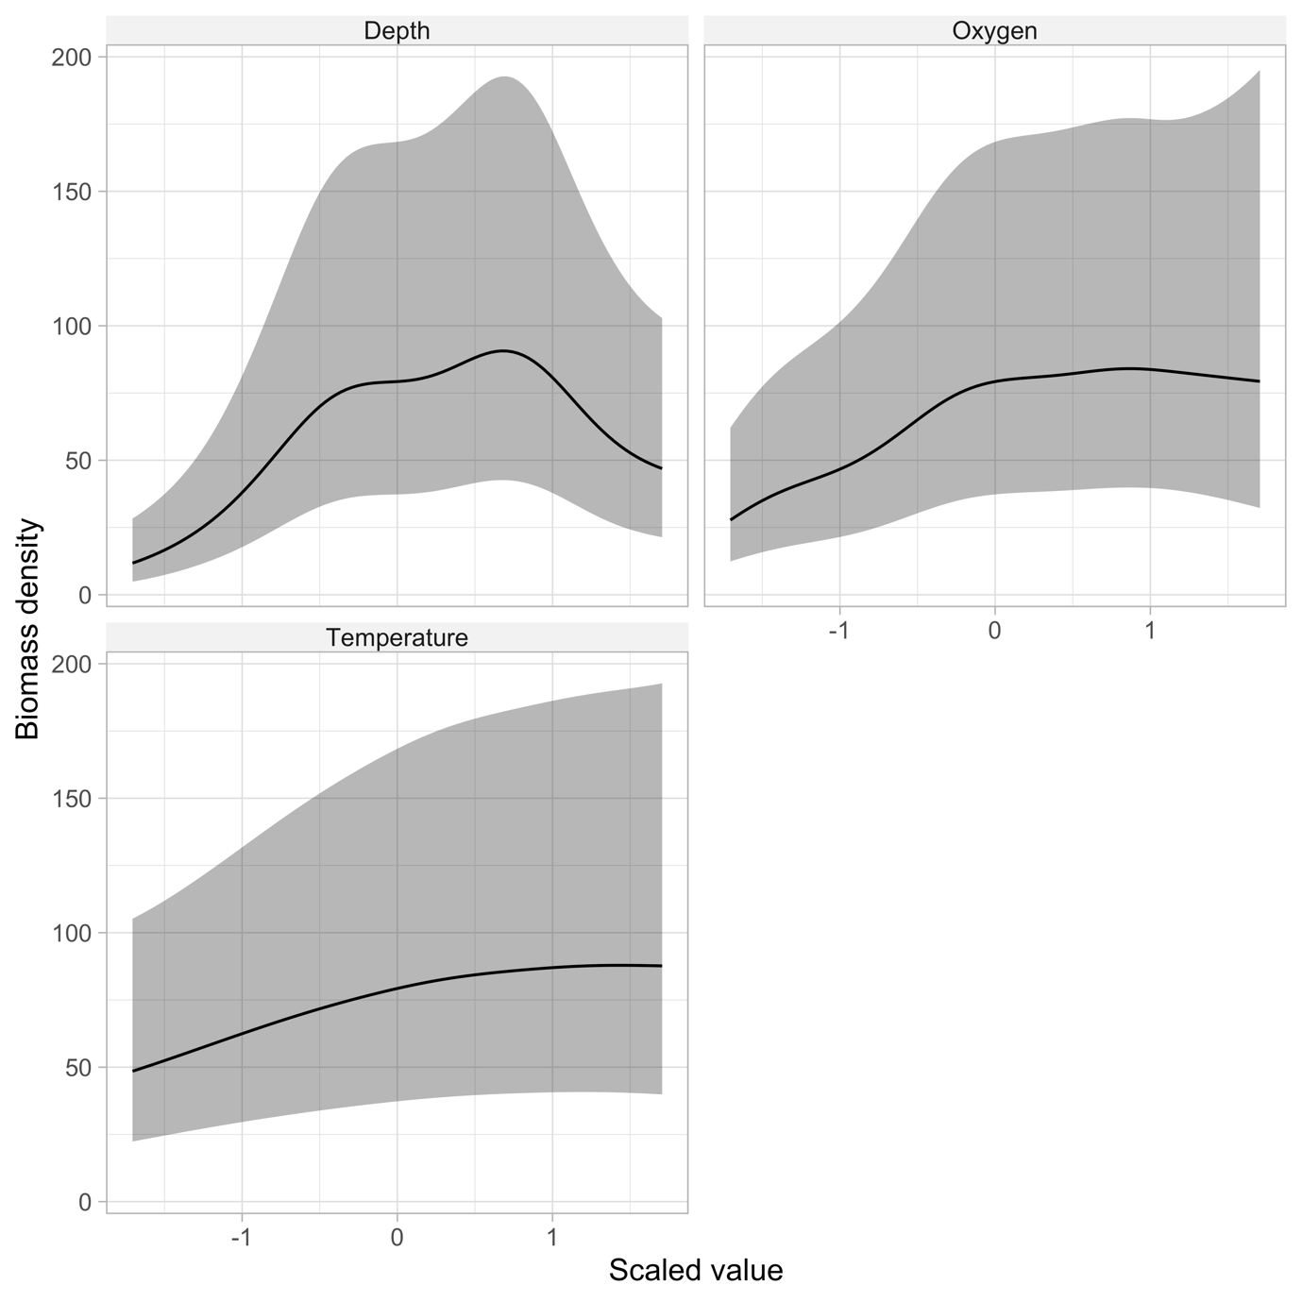

Fig. S22. Conditional effects from the cod density model.

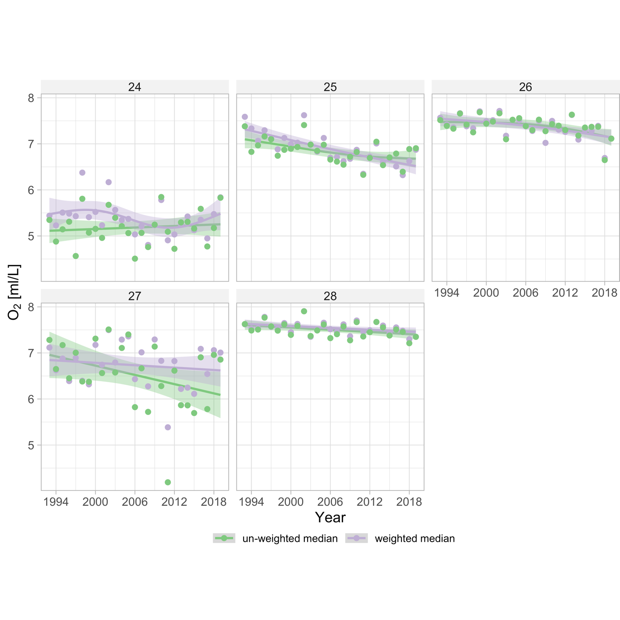

Fig. S23. Biomass-weighted (purple) and unweighted (green) sea bottom oxygen by sub-division. Lines depict GAM fits ($k$ =4) fits and the shaded area depicts the 95% confidence intervals.

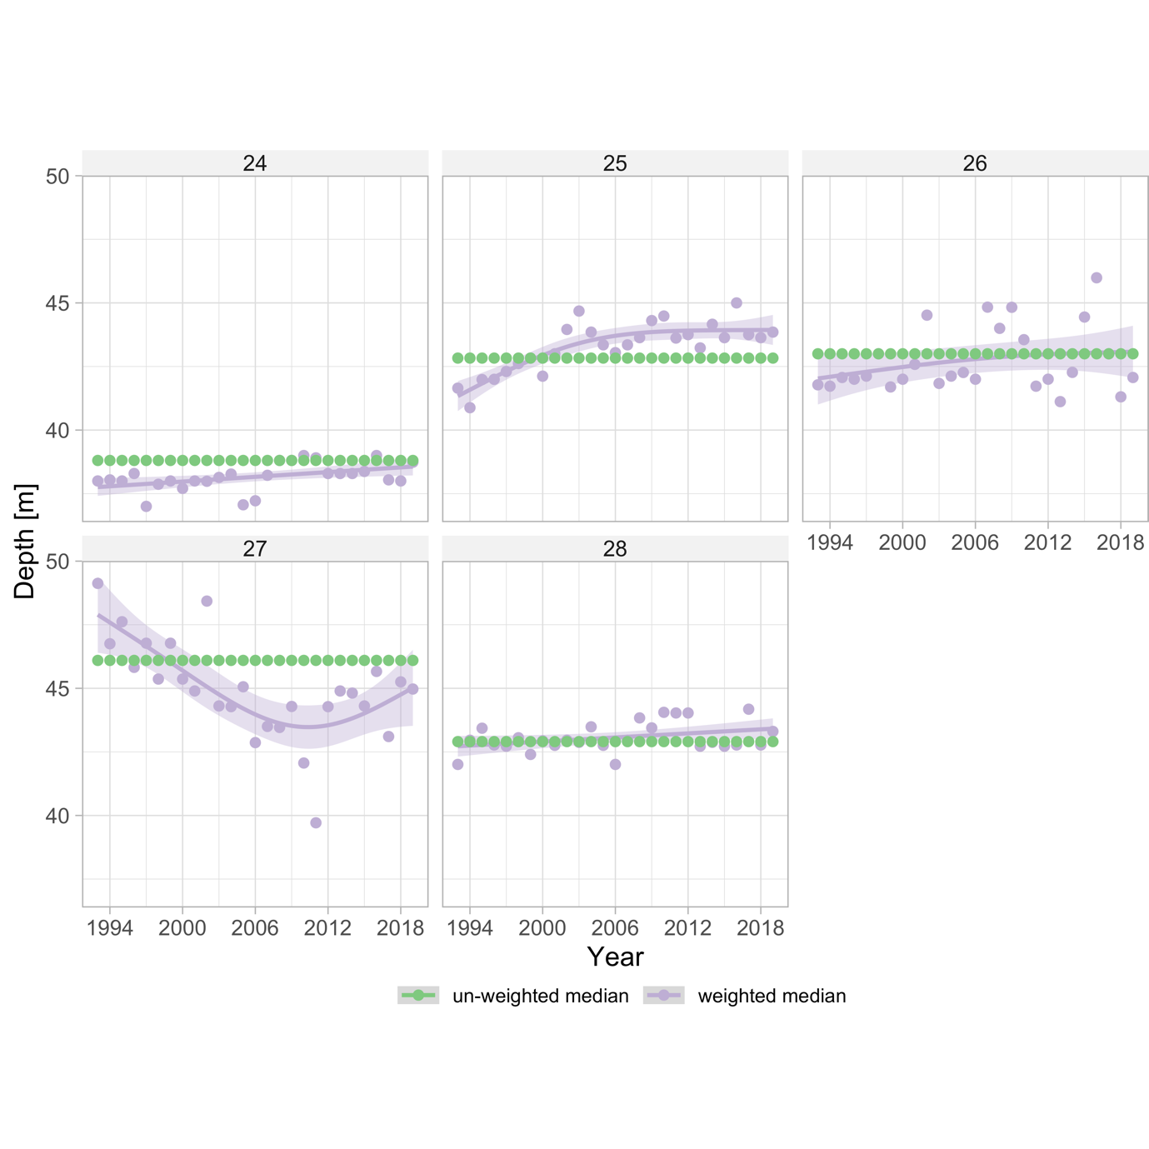

Fig. S24. Biomass-weighted (purple) and unweighted (green) depth by sub-division. Lines depict GAM fits ($k$ =4) fits and the shaded area depicts the 95% confidence intervals.

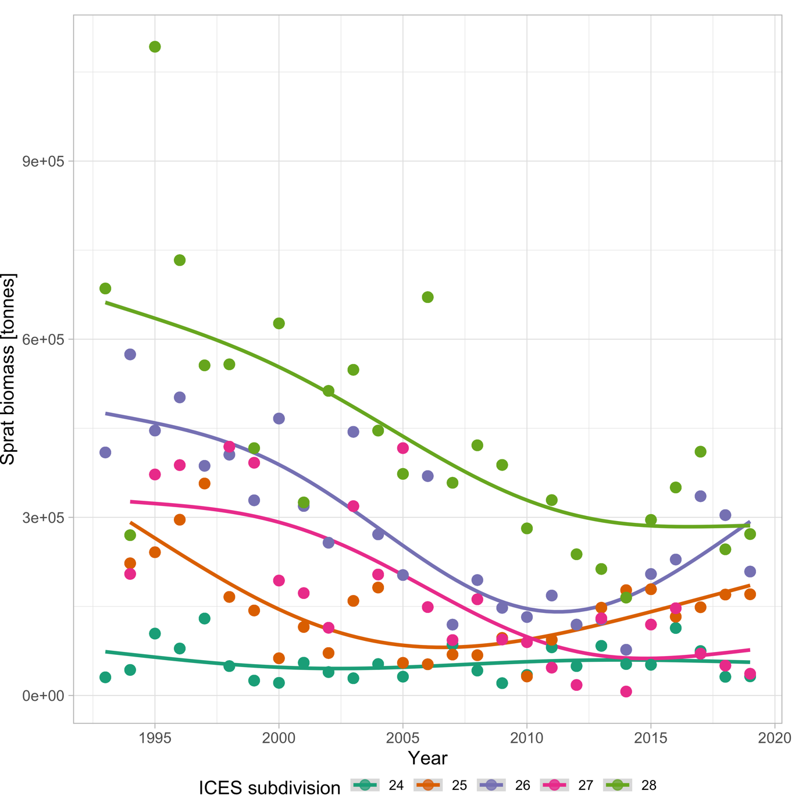

Fig. S25. Biomass of sprat over time by sub-division. Lines depict GAM fits ($k$ =4) fits.

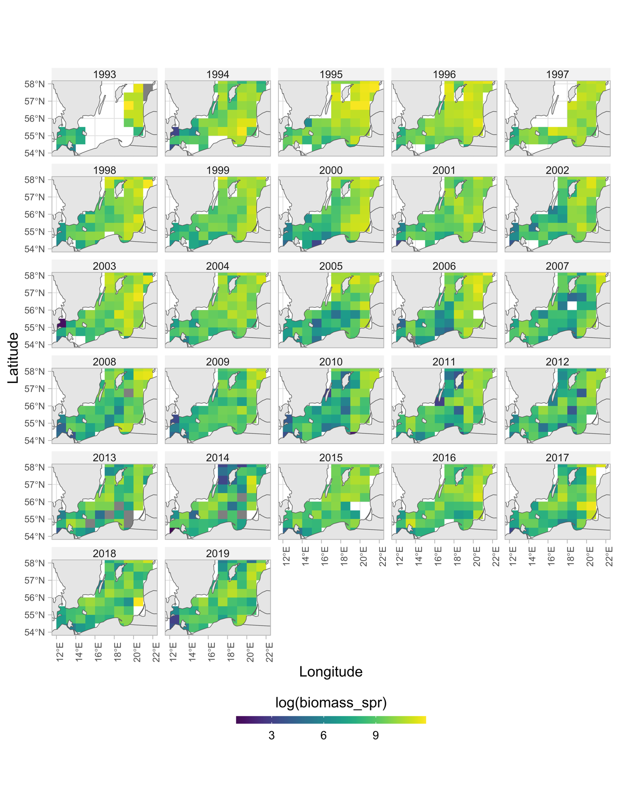

Fig. S26. Rectangle-level log biomass of sprat indicating rectangles with missing values.

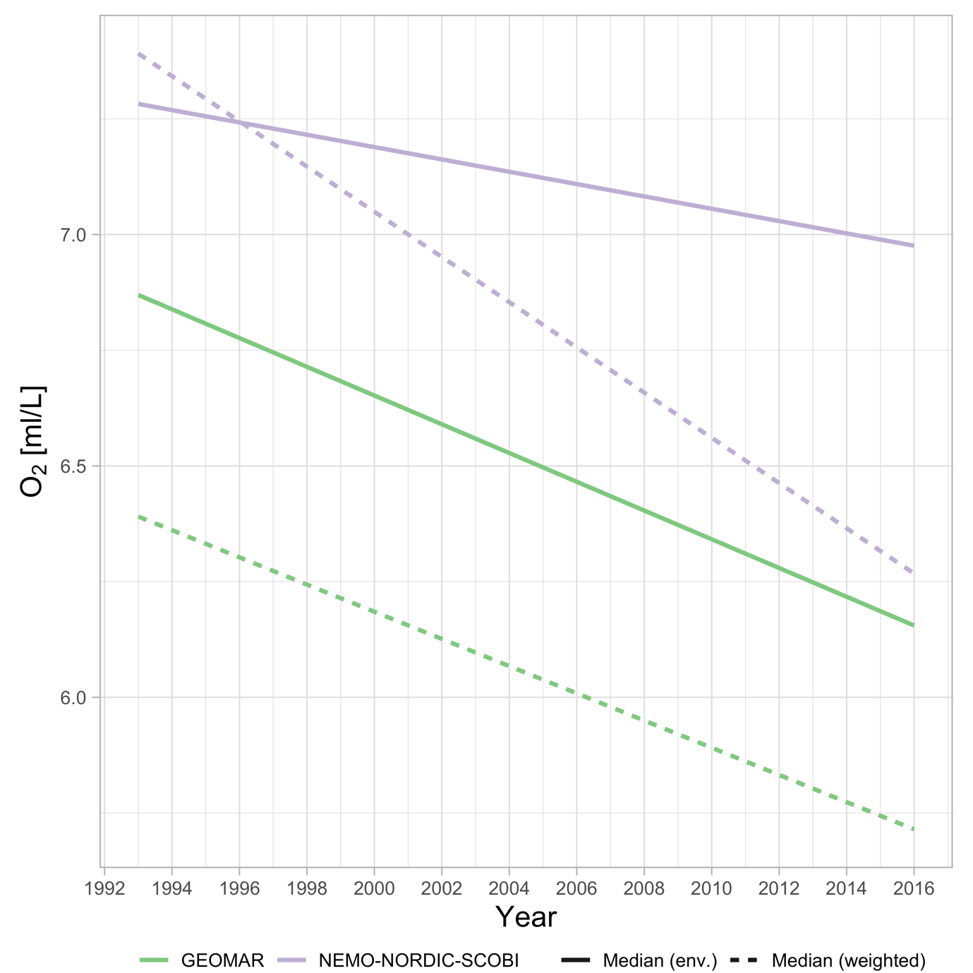

Fig. S27. Comparison of oxygen concentrations between the “GEOMAR” model used in Lehmann et al., (Lehmann *et al.*, 2002, 2014) (green lines) and the (Eilola *et al.*, 2009; Almroth-Rosell *et al.*, 2011; Hordoir *et al.*, 2019) NEMO-NORDIC-SCOBI models (purple lines) in ICES subdivision 25 between 1993–2016. Solid lines depict the median in the environment in the interquartile depth range (29-61 m), and dashed lines depict the median oxygen concentration weighted by the predicted biomass density of cod.

# **Literature cited**

Almroth-Rosell, E., Eilola, K., Hordoir, R., Meier, H. E. M., and Hall, P. O. J. 2011. Transport of fresh and resuspended particulate organic material in the Baltic Sea — a model study. Journal of Marine Systems, 87: 1–12.

Eilola, K., Meier, H. E. M., and Almroth, E. 2009. On the dynamics of oxygen, phosphorus and cyanobacteria in the Baltic Sea; A model study. Journal of Marine Systems, 75: 163–184.

Hordoir, R., Axell, L., Höglund, A., Dieterich, C., Fransner, F., Gröger, M., Liu, Y., *et al.* 2019. Nemo-Nordic 1.0: a NEMO-based ocean model for the Baltic and North seas – research and operational applications. Geoscientific Model Development, 12: 363–386. Copernicus GmbH.

Lehmann, A., Krauss, W., and Hinrichsen, H.-H. 2002. Effects of remote and local atmospheric forcing on circulation and upwelling in the Baltic Sea. Tellus A, 54: 299–316.

Lehmann, A., Hinrichsen, H.-H., Getzlaff, K., and Myrberg, K. 2014. Quantifying the heterogeneity of hypoxic and anoxic areas in the Baltic Sea by a simplified coupled hydrodynamic-oxygen consumption model approach. Journal of Marine Systems, 134: 20–28.

Monnahan, C. C., and Kristensen, K. 2018. No-U-turn sampling for fast Bayesian inference in ADMB and TMB: Introducing the adnuts and tmbstan R packages. PLOS ONE, 13: e0197954. Public Library of Science.

Rufener, M.-C., Kristensen, K., Nielsen, J. R., and Bastardie, F. 2021. Bridging the gap between commercial fisheries and survey data to model the spatiotemporal dynamics of marine species. Ecological Applications, 31: e02453.

Stan Development Team. 2022. Stan Modeling Language Users Guide and Reference Manual, 2.30. https://mc-stan.org. https://mc-stan.org.

Thygesen, U. H., Albertsen, C. M., Berg, C. W., Kristensen, K., and Nielsen, A. 2017. Validation of ecological state space models using the Laplace approximation. Environmental and Ecological Statistics, 24: 317–339.